Hobbies Activity Badge 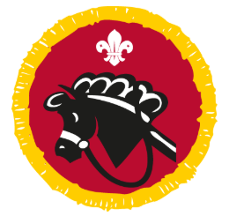
How to earn your badge
- Over three months, be actively involved in a hobby of your choice.
- Show and explain to your leader or Explorer Scout Young Leader what equipment, materials and background information you have used to take part in your hobby including any safety rules.
- Talk about your hobby including why you have chosen it and what you enjoy about it.
- Talk to your leader about how you plan to develop your hobby, interest or skill in the future.

I confirm that................................................................has met the above stated requirements 1 for the Hobbies Badge.

Signed..........................................................................

Date ......./......../...........

Please bring this form to a meeting along with the everything you need to complete requirements 2, 3 & 4.

Leaders Signature………………………………………………………………..

